Lab 2: Build Tab App - Embedded web experiences with tabs

Before Start the application verify the application (One time activity)
- Install node LTS version (16.16)
Open Command Prompt and enter node -v
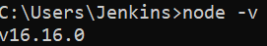
- Install Visual studio code https://code.visualstudio.com/
- Install Yeoman and Gulp CLI npm install yo gulp-cli –global
- Install the Microsoft Teams Apps generator - Yo Teams
  - npm install generator-teams –global

Following are the steps to create a personal tab:
- Generate your application with a personal tab
- Add a content page to the personal tab
- Create your app package
- Build and run your application
- Establish a secure tunnel to your personal tab
- Upload your application to Teams

Generate your application with a personal tab
- Create an App
- Go to you Project folder and create a new folder “PersonalTabApp”
- At the command prompt, create a new directory for your personal tab.
- Enter the following command in your new directory to start the Microsoft Teams App generator: yo teams
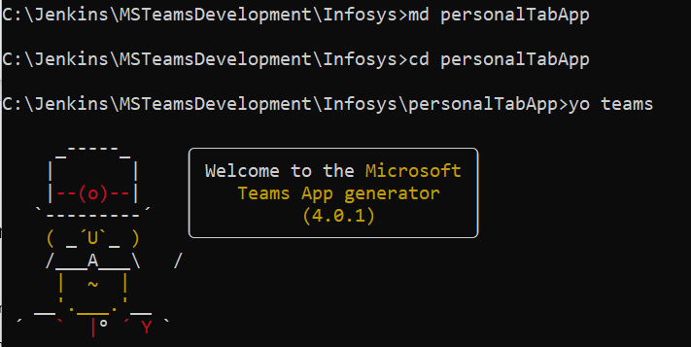
- Create a solution, Series of questions to update your manifest.json file
- After completing the creation process, open the app using visual studio code
- Without changing any code run below command to execute the tab locally using ngrok
gulp ngrok-serve
- To check locally using local host - http://localhost:3007/personalTabAppTab/index.html
- Refer the manifest and see the scope is personal
- Then go to teams and add this app manifest without stopping the application
- Go to teams https://teams.microsoft.com
- Click Apps
- Click Manage your apps
- Click Upload an app to upload the package.zip file
- Select upload a customized apps
- Package file available in your project folder
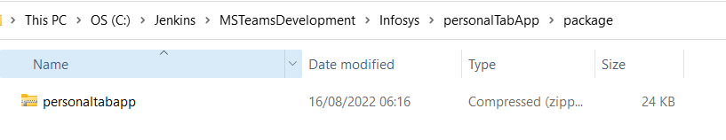
- Click Add to add the personal app
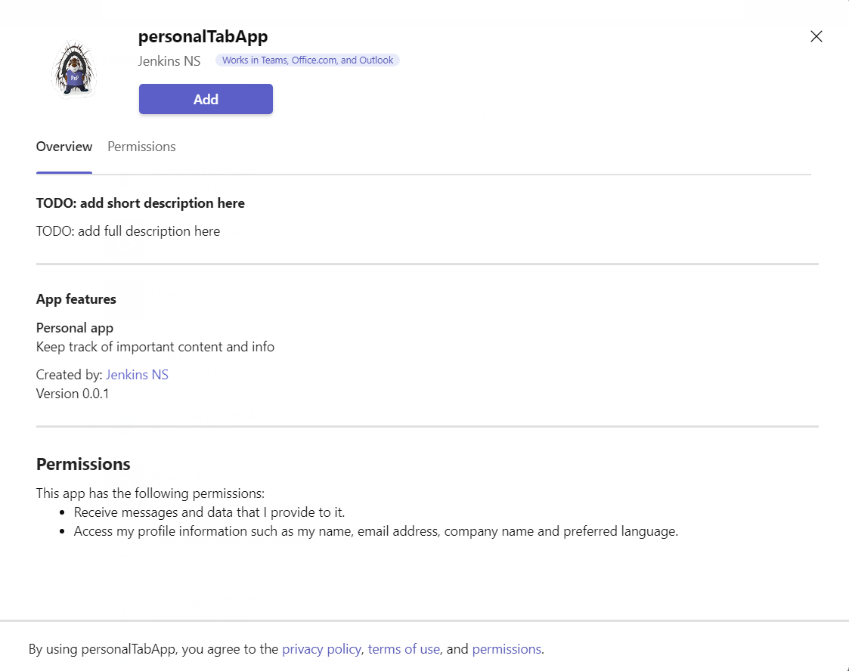
- It will load the below tab
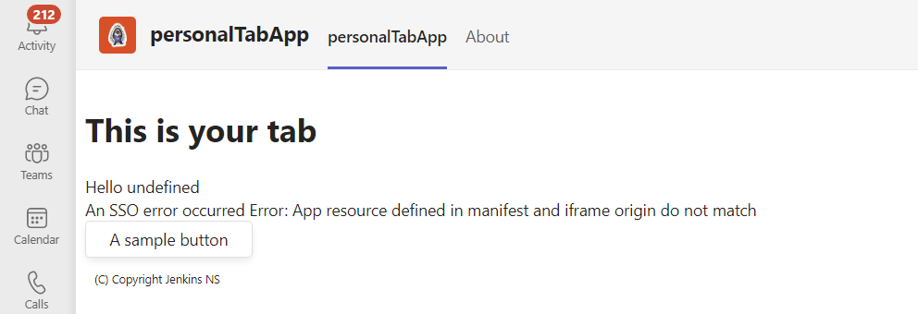
- You can see that your name and SSO missing
- To add SSO
Create an app registration in Azure AD
Register a new app in Azure AD and configure the tenancy and app's platform. You'll generate a new app ID that will be updated later in your Teams app manifest file.
To register a new app in Azure AD
- Open the Azure portal on your web browser. The Microsoft Azure AD Portal page opens.
- Select the App registrations icon - The App registrations page appears.
- Select + New registration icon.
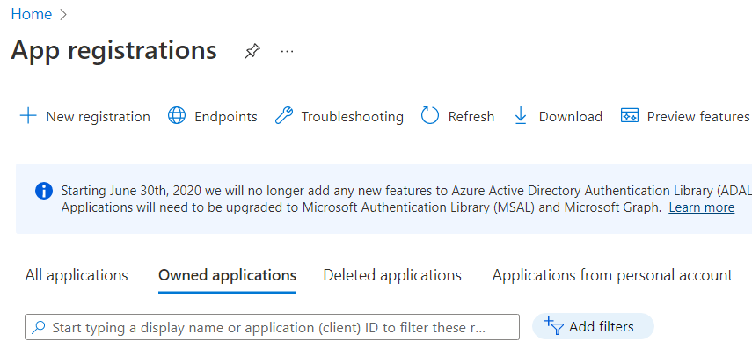
- The Register an application page appears.
- Enter the name of your app that you want to be displayed to the app user. You can change this name at a later stage, if you want to.
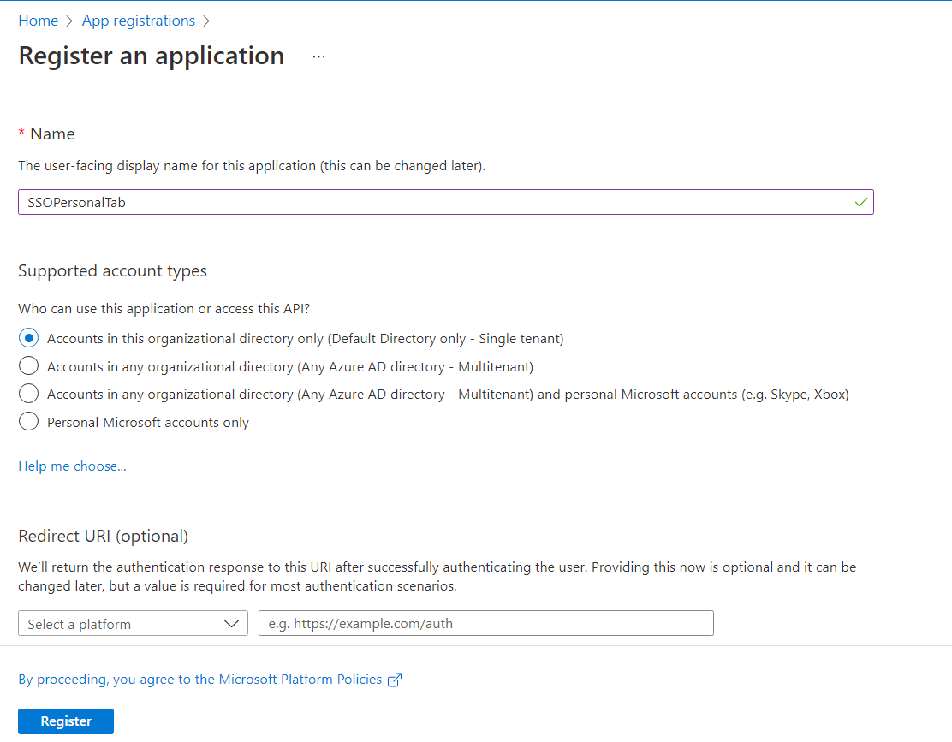
- Select Register. A message pops up on the browser stating that the app was created.
- Note and save the app ID from Application (client) ID. You'll need it for updating the Teams app manifest later.
- Your app is registered in Azure AD. You should now have app ID for your tab app.

Configure scope for access token
After you've created a new app registration, configure scope (permission) options for sending access token to Teams Client, and authorizing trusted client applications to enable SSO.
To expose an API
Select Manage > Expose an API from the left pane.
The Expose an API page appears.
Select Set to generate application ID URI in the form of api://{AppID}.
The application ID URI format should be: api://fully-qualified-domain-name.com/{AppID}.
Click Save and continue
Add scope
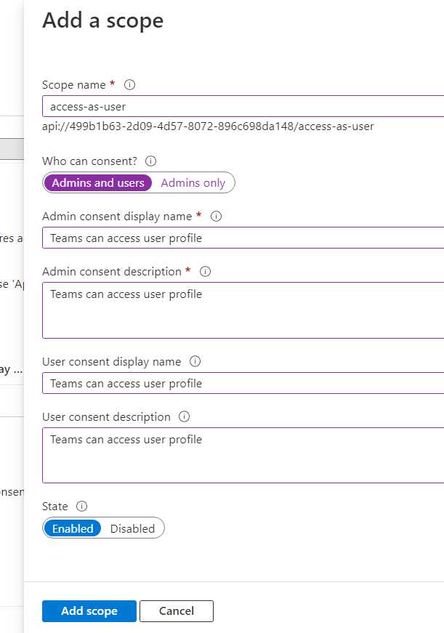
Click Add scope

9
Generate your application with a Customizable tab (Channel / group chat)
- Create an App
- Go to you Project folder and create a new folder “configurableTabApp”
- At the command prompt, create a new directory for your personal tab.
- Enter the following command in your new directory to start the Microsoft Teams App generator: yo teams
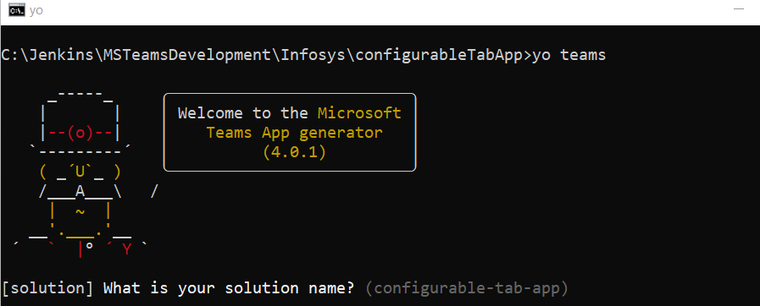
Open the project using code .
Build gulp ngrok-serve
Then follow the same personal app steps.

